Federal State Budgetary Educational Institution of Higher Education «Kazan National Research Technical University named after A.N. Tupolev–KAI»

### German-Russian Institute of Advanced Technologies

### Research in Computer and Systems Engineering

INSTRUCTIONS

to the practical work No. 1

by discipline "Basics of Neural Networks "

"Introduction into artificial neural networks. Preliminaries. Linear Neural Networks"

### Kazan - 2020

**PRACTICAL WORK No. 1**

**Name of practical work**

Introduction into artificial neural networks. Preliminaries. Linear Neural Networks.

**The goal of practical work**

Get on the environment configuration knowledge and practical skills for the calculation of machine learning algorithms.

**TASK FOR PRACTICAL WORK**

1. Software installation:
   1. Download Anaconda3. Anaconda3 is a distribution of Python programming languages that includes a set of popular free libraries, combined with problems of data science and machine learning. For the Python 3.7 language version, in accordance with the operating system of your machine, you need to download the installation file from the [link](https://www.anaconda.com/distribution/): https://www.anaconda.com/distribution/. In fig. 1-2 shows the steps for downloading Anaconda3.

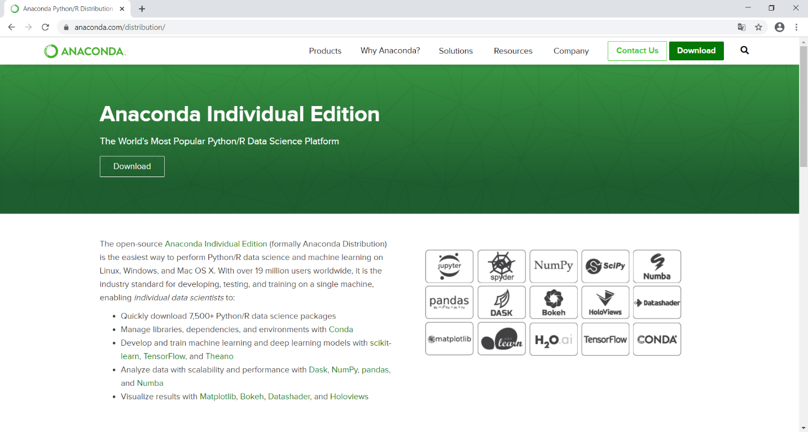

Fig. 1. Official website of Anaconda3

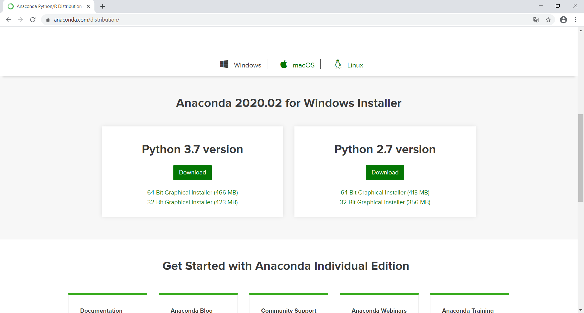

Fig. 2. Choosing Python 3.7 according to OS

* 1. Installing the Anaconda3. When installing, step by step perform the following actions shown in fig. 3-10

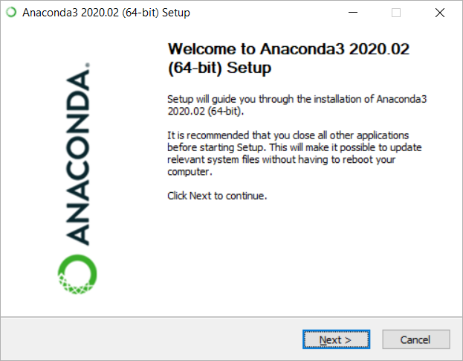

Fig. 3. Start the setup

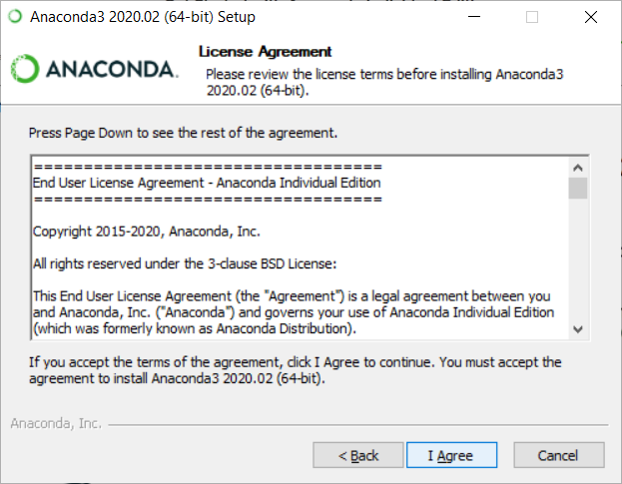

Fig. 4. License Agreement

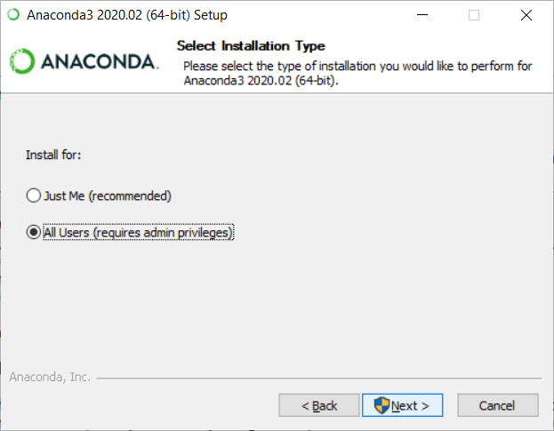

Fig. 5. Set the rights for all users

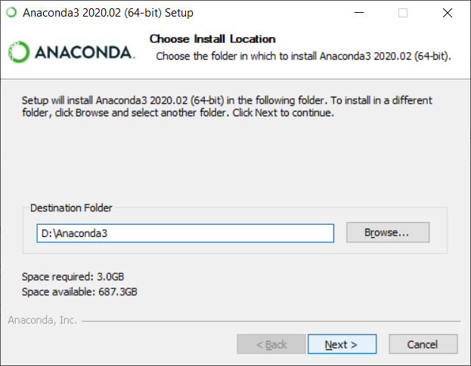

Fig. 6. Choose install location

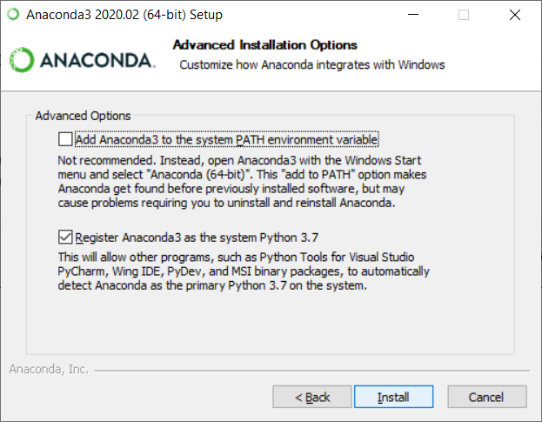

Fig. 7. Program’s registration

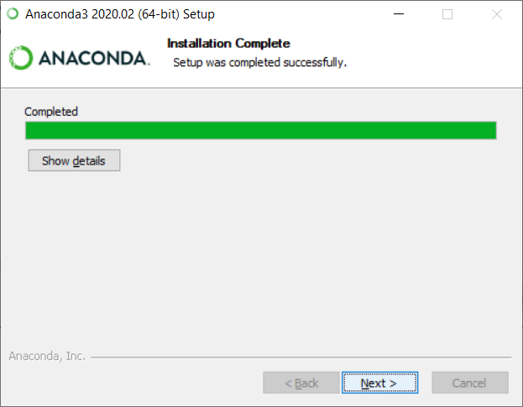

Fig. 8. Installation

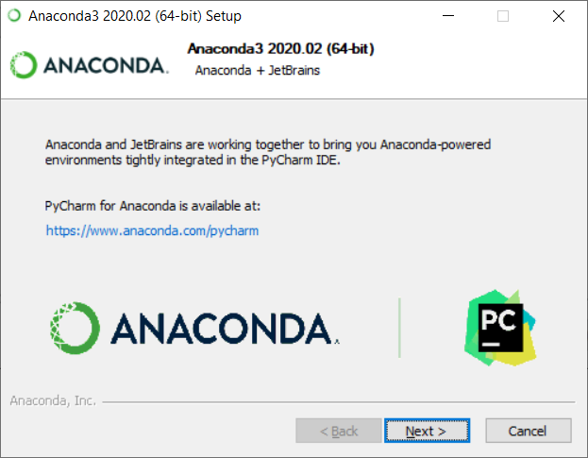

Fig. 9. End of the Setup

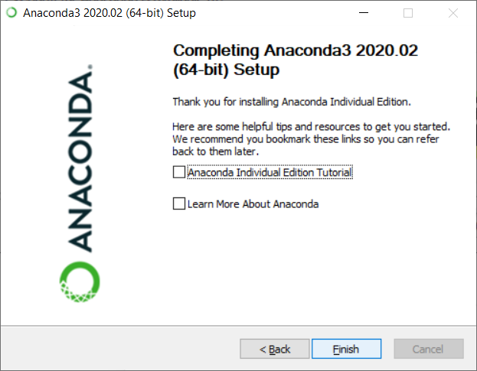

Fig. 10. Completing the Setup

2. The next step is to create a new virtual environment. The main task of the Python virtual environment is to create an isolated environment with the necessary dependencies for a specific Python project.

The creation of a new virtual environment for the project is shown in Fig. 11-15.

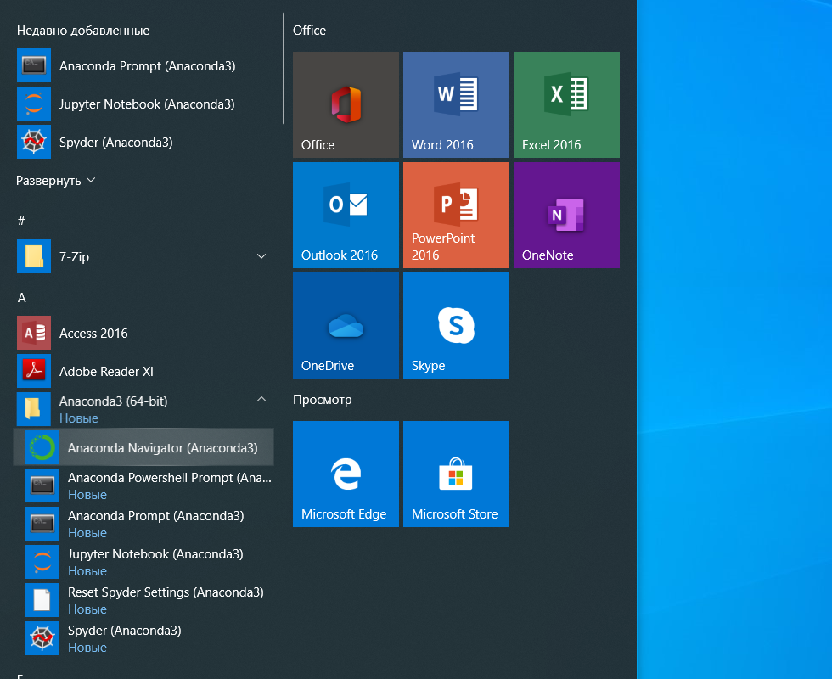

Fig. 11. In the start menu, find Anaconda Navigator (Anaconda3)

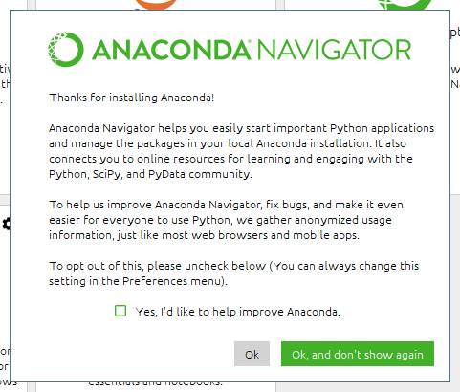

Fig. 12. You are asked to send materials for research. You don't have to send them if you like. Uncheck the box and click OK

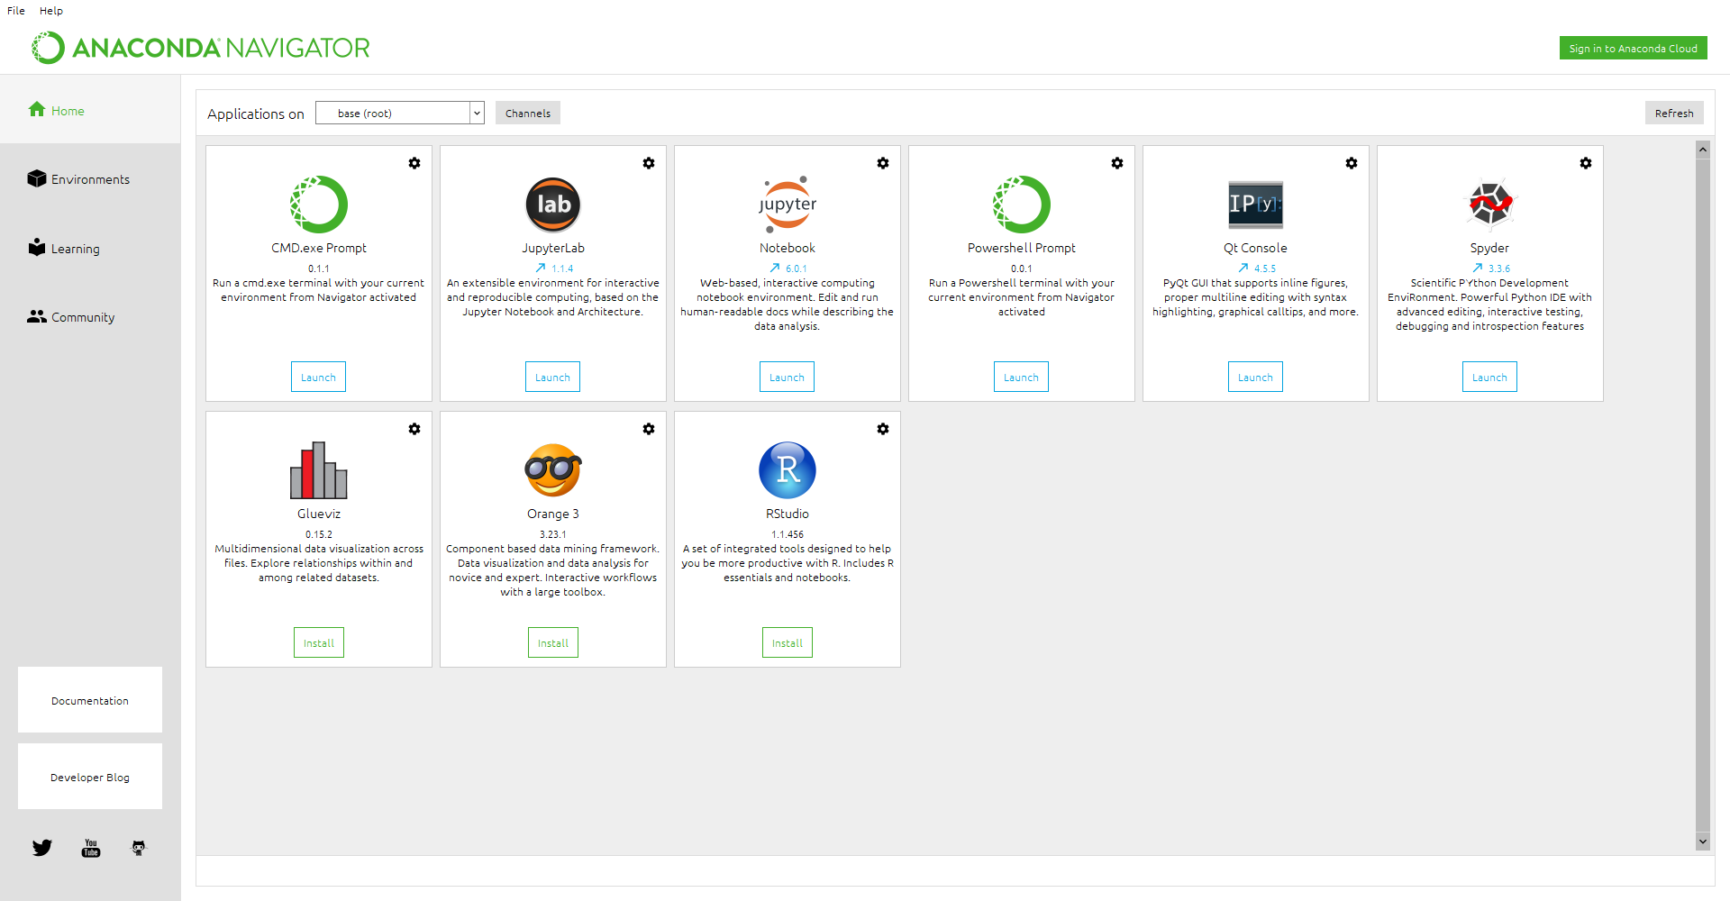

Fig. 13. Select the Environments tab

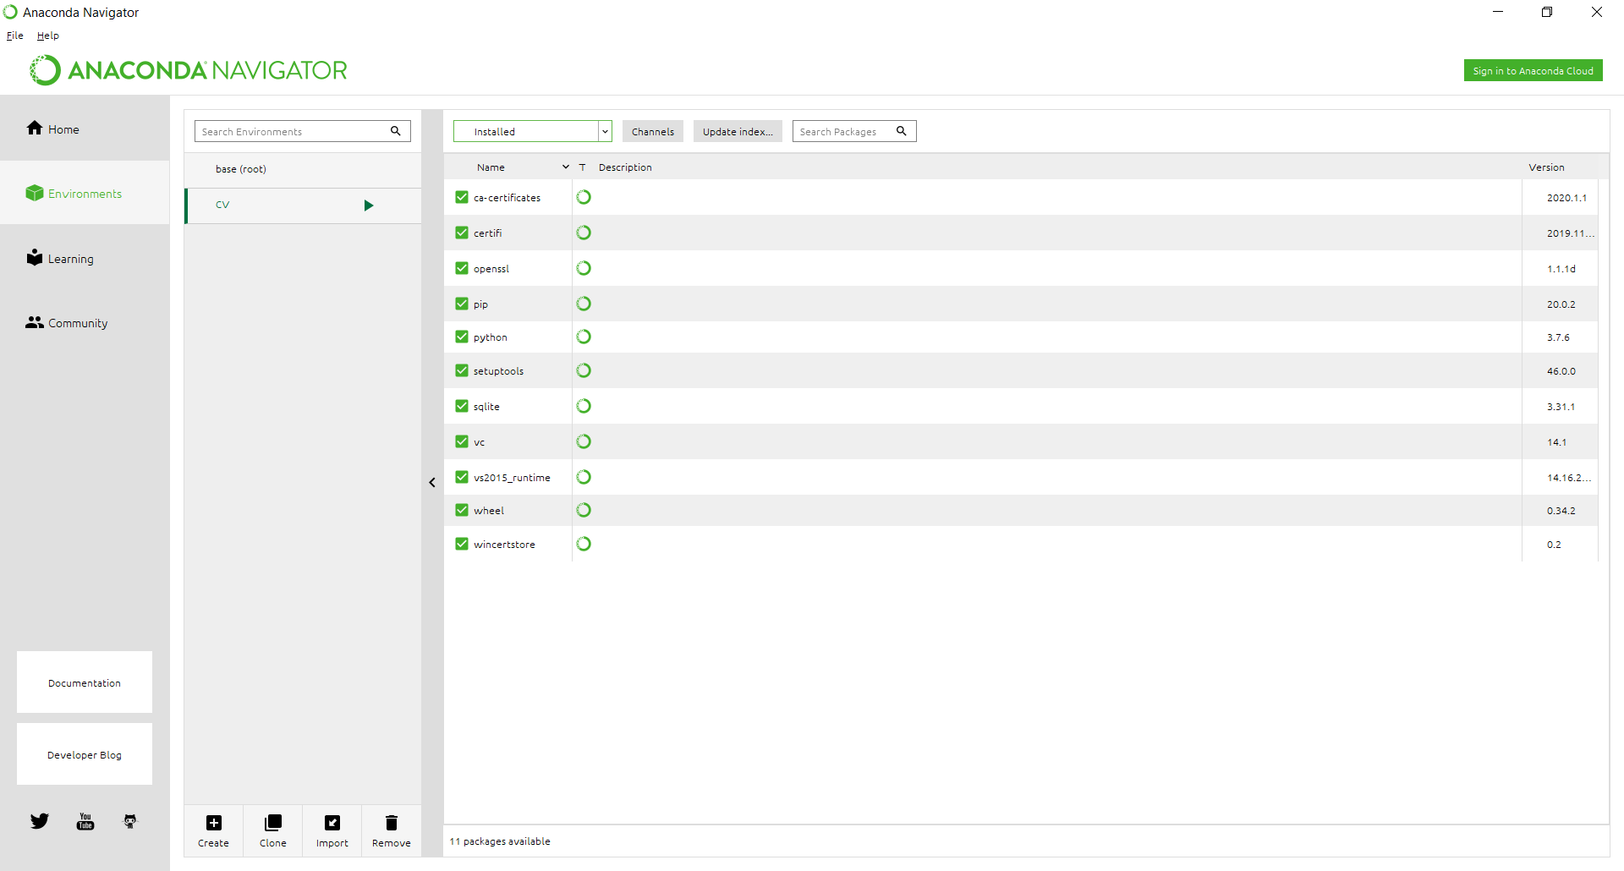

Fig. 14. Click Create

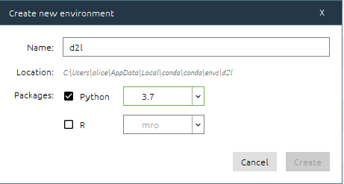

Fig. 15. Select the virtual environment name, Python 3.7 package, click Create

3. Installing libraries required for work:

1. Installing Jupyter notebook:

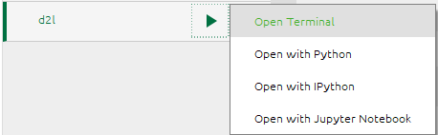

Fig. 16. Select the created virtual environment, press Open Terminal

Command to start jupyter notebook installation: conda install jupyter

It is necessary to confirm the installation by selecting the command: y (further, when this message appears, you must confirm the installation): 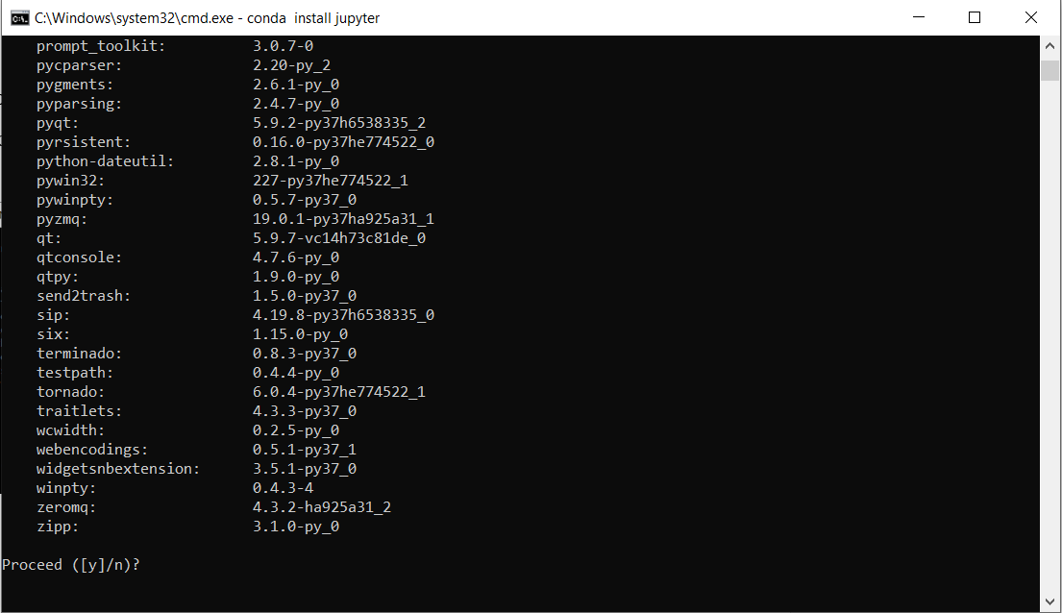

Fig. 17. Installation confirmation

b. Installation of TensorFlow with both CPU and GPU support via the following Starting the TensorFlow installation with the command: pip install tensorflow==2.2.0 tensorflow-probability==0.10.0

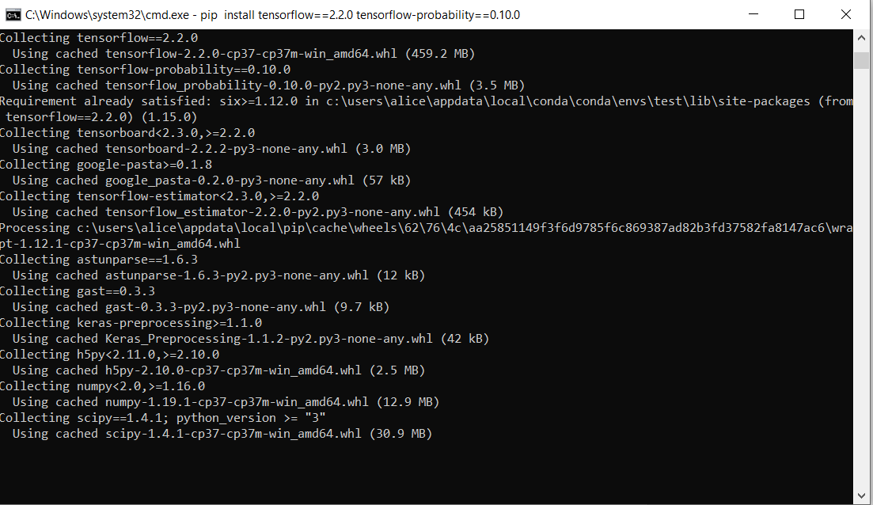

Fig. 18. Running TensorFlow installation

We also install the d2l package that encapsulates frequently used functions and classes in this book.

Command to start d2l installation: pip install -U d2l

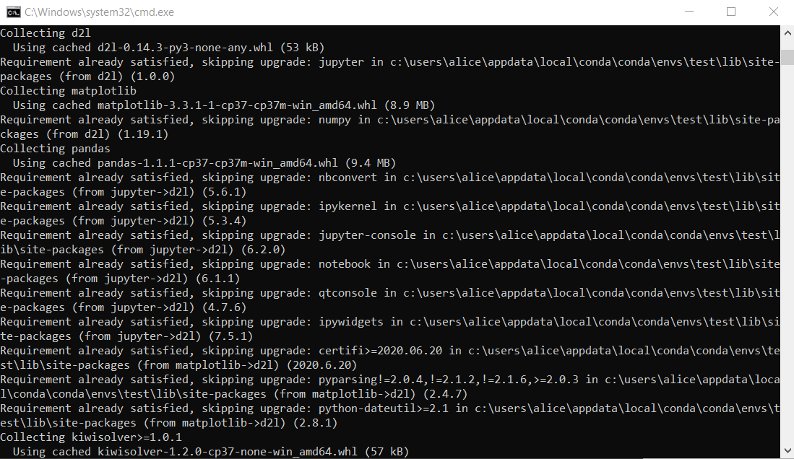

Fig. 21. d2l installation

4. Working with the program in jupyter notebook:

a. Open the console of the created virtual environment:



Fig. 22. Открытие консоли созданной виртуальной среды

Go to the folder with the laboratory work by entering the command:

cd address of the folder

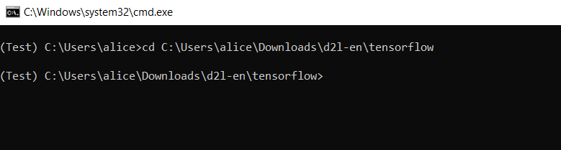

Fig. 23. Go to the lab folder

Run jupyter notebook with the command: jupyter notebook

Jupyter notebook consists of a sequence of cells. A cell is a multi-line text entry field, and you can execute its contents by clicking the Play button on the toolbar. Code cells can be run in any order you want. If the code takes too long to execute and you want to interrupt it, you can click the Stop button.

Further, to work with the code in this work, it is necessary to sequentially launch the blocks using Run.

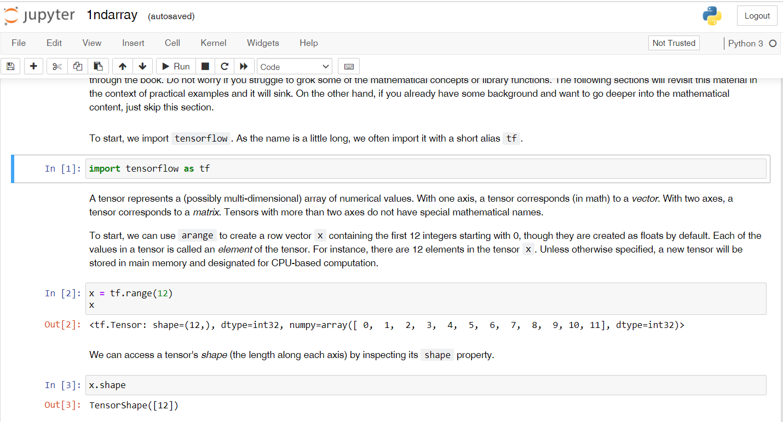

Fig. 24. Jupyter notebook interface

**PRACTICE REPORT**

**Name of practical work**

Introduction into artificial neural networks. Preliminaries. Linear Neural Networks.

**The goal of practical work**

Get on the environment configuration knowledge and practical skills for the calculation of machine learning algorithms.

**Done by**

Group № ______

Student’s Name, Last name ______________________________________________

**The report is received in the form of an executable file for Jupyter Notebook or link to the Google Colab**

**Task:**

1) Setup the environment and run all the notebooks

2) Find the dataset and provide some description for the dataset:

[Google Dataset Search](https://datasetsearch.research.google.com/): Similar to how Google Scholar works, Dataset Search lets you find datasets wherever they are hosted, whether it’s a publisher’s site, a digital library, or an author’s web page. It’s a phenomenal dataset finder, and it contains over 25 million datasets.

[Kaggle](https://www.kaggle.com/): Kaggle provides a vast container of datasets, sufficient for the enthusiast to the expert.

[UCI Machine Learning Repository](https://archive.ics.uci.edu/ml/index.php): The Machine Learning Repository at UCI provides an up to date resource for open-source datasets.

[CMU Libraries](https://guides.library.cmu.edu/machine-learning/datasets): Discover high-quality datasets thanks to the collection of Huajin Wang, at CMU.